1. PG Tokenization MS
1.1. Use case 1: Realtime Token Conversion
1.2. Use case 2: Batch Token Conversion
1.3. API 1: createPgtoken
1.3.1. Integration Details
1.3.2. Headers
1.3.3. Request Parameters Input (GetPGToken_Req)
1.3.4. Input Validation
1.3.5. Response Parameters (GetPGToken_Res )
1.3.6. Create PG Token API Logic
1.3.7. Error Codes
1.4. API2: Submit Batch
1.4.1. Integration Details
1.4.2. Headers
1.4.3. Request Parameters Input
1.4.4. Input Validation
1.4.5. Response Parameters
1.4.6. Submit Batch API Logic
1.4.7. Error Codes
1.5. API3: Get Batch Status
1.5.1. Integration Details
1.5.2. Headers
1.5.3. Request Parameters Input
1.5.4. Input Validation
1.5.5. Response Parameters
1.5.6. Get Batch Status API Logic
1.5.7. Error Codes
1.6. API4: Get Batch Result
1.6.1. Integration Details
1.6.2. Headers
1.6.3. Request Parameters Input
1.6.4. Input Validation
1.6.5. Response Parameters
1.6.6. Get Batch Result API Logic
1.6.7. Error Codes
2. PG Dispatcher MS
2.1. API 1: createPgtoken
2.1.1. Integration Details
2.1.2. Headers
2.1.3. Request Parameters Input (GetPGToken_Req)
2.1.4. Input Validation
2.1.5. Response Parameters (GetPGToken_Res )
2.1.6. Create PG Token API Logic
2.1.7. Error Codes
2.2. API2: Submit Batch
2.2.1. Integration Details
2.2.2. Headers
2.2.3. Request Parameters Input
2.2.4. Input Validation
2.2.5. Response Parameters
2.2.6. Submit Batch API Logic
2.2.7. Error Codes
2.3. API3: Get Batch Status
2.3.1. Integration Details
2.3.2. Headers
2.3.3. Request Parameters Input
2.3.4. Input Validation
2.3.5. Response Parameters
2.3.6. Get Batch Status API Logic
2.3.7. Error Codes
2.4. API4: Get Batch Result
2.4.1. Integration Details
2.4.2. Headers
2.4.3. Request Parameters Input
2.4.4. Input Validation
2.4.5. Response Parameters
2.4.6. Get Batch Result API Logic
2.4.7. Error Codes

PG Tokenization MS

Use case 1: Realtime Token Conversion
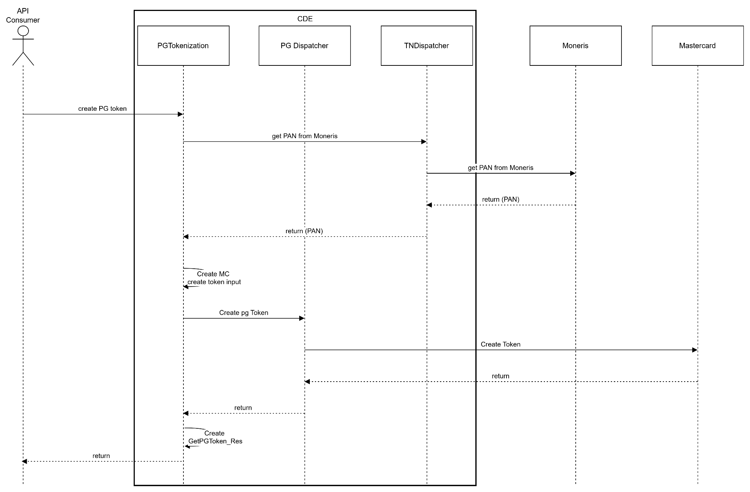

Use case 2: Batch Token Conversion
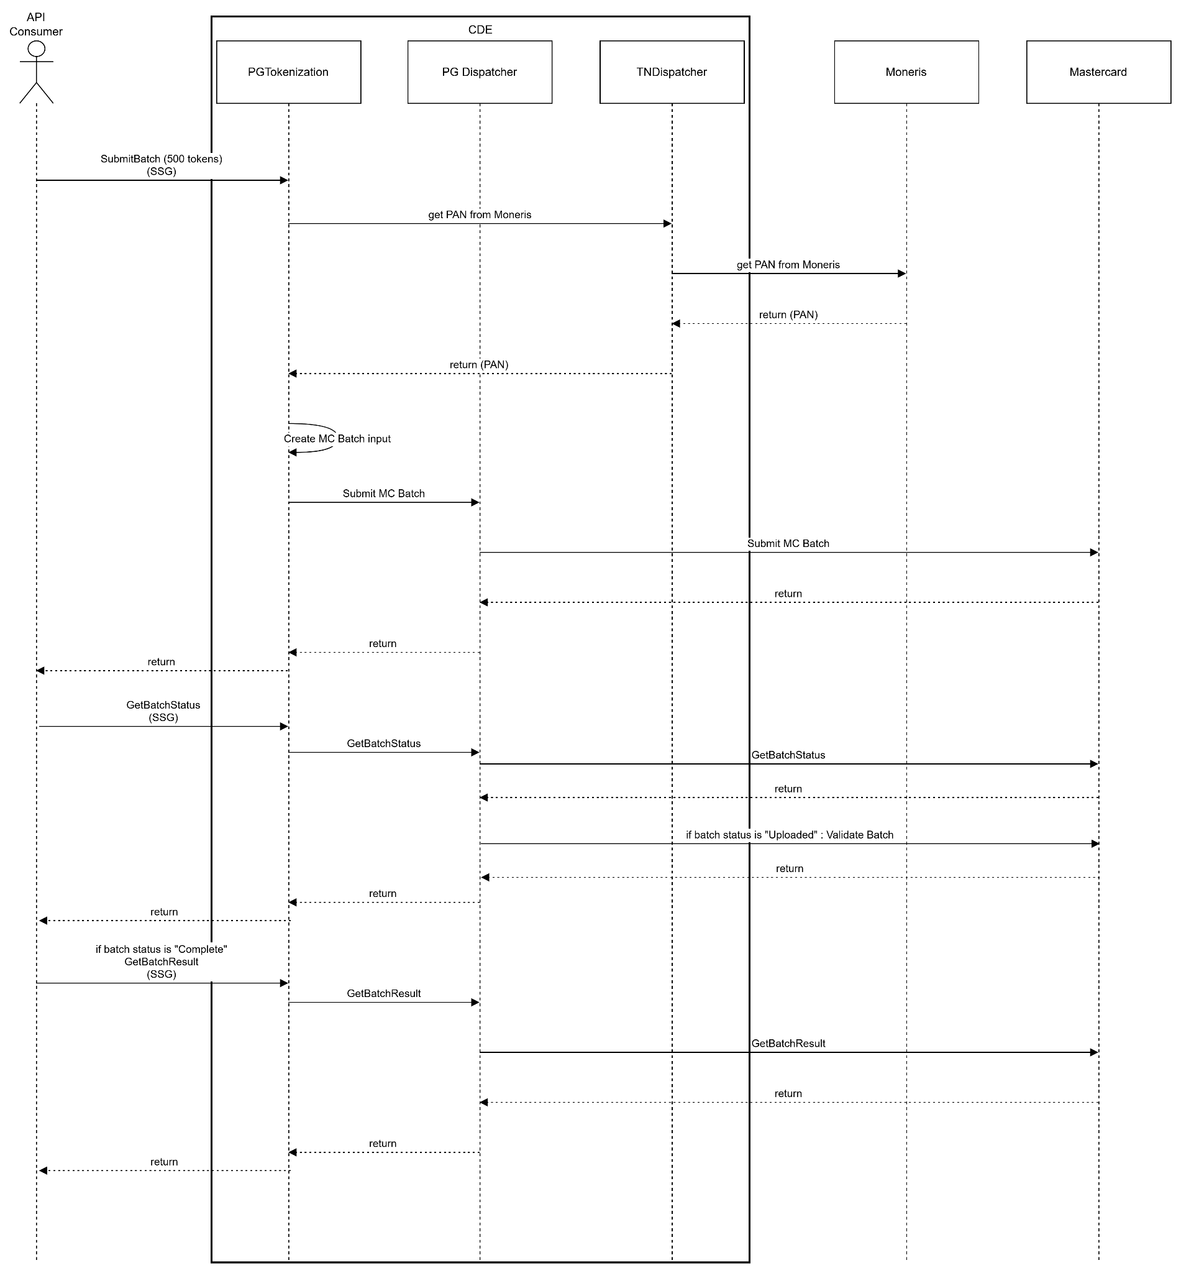

API 1: createPgtoken
This operation is used to retrieve PG token info.

Integration Details
URL | TBD
HTTP Type | POST
Content Type | application/json
Security | N/A

Headers
TBD

Request Parameters Input (GetPGToken_Req)
All following field names will be under GetPGToken_Req object
Field Name | Description | Sample value | Mandatory | Data Type | Default Value
monerisToken.token | Moneris token  16 digits starting with 9 | 9145678654321 | Y | string
monerisToken.expiryDate | Expiration date of Moneris token. May be expired MMYY |  | Y | string
correlatorId | Unique identifier in the client for the payment method in case it is needed to correlate.  maxLength: 64 |  | Y | string
channel.businessUnit | minLength: 2  example: WL,FD  maxLength: 2  Line of business (value defined by CASH) | WL | Y | string

Input Validation
N/A

Response Parameters (GetPGToken_Res )
All following field names will be under GetPGToken_Res object
Field Name | Description | Sample value | Mandatory | Data Type
channel.businessUnit | minLength: 2  example: WL,FD  maxLength: 2  Line of business (value defined by CASH) | WL | Y | string
@type | maxLength: 1  example: 1 = Credit Card/Token,2 = Apple Pay,3 = Google Pay,4 = VI SRC  Type of payment method (e.g.: credit card, bank card, cash, voucher, etc). |  | Y | string
paymentMethodObject.token | example: 9145678654321  Tokenized representation of the card number (created by payment gateway). |  |  | string
paymentMethodObject.expirationDate | example: 1126  Card Expiry date |  |  | string
paymentMethodObject.cardBrand | example: VI (Visa), MC (Mastercard), AX (Amex)  Card network brand |  |  | string
paymentMethodObject.cardLastFour | maxLength: 4  last four digits of the original card |  |  | string
paymentMethodObject.bin | example: 554887  Bank Identification Number - First six of the card |  |  | string
paymentMethodObject.issuer.issuerName | example: Rogers Bank  Name of the card issuer |  |  | string
paymentMethodObject.issuer.issuerCountryCode | example: GBR  The country code of the card issuer, if known. |  |  | string
paymentMethodObject.issuer.cardLevel | example: WORLD ELITE/STANDARD  Card product level or tier |  |  | string
paymentMethodObject.issuer.tags | metadata of issuer details |  |  | string
paymentMethodObject.fundingSource | example: CREDIT, DEBIT, PREPAID  Indicates whether the card is credit, debit, or prepaid |  |  | string
paymentMethodObject.createdDate | PG Token creation date |  |  | string
paymentMethodObject.lastUpdatedDate | PG Token last updated date |  |  | string

Create PG Token API Logic
- Invoke TNDispatcher (or TSI) to detokenize Moneris token
- Identify merchant id from business unit
- Invoke PGDispatcher to create mastercard token from PAN details retrieved from TNDispatcher

Error Codes
TBD

API2: Submit Batch
This operation is used to retrieve PG token info.

Integration Details
URL | N/A
HTTP Type | POST
Content Type | application/json
Security | N/A

Headers
TBD

Request Parameters Input
Array of GetPGToken_Req with following additional field

Field Name | Description | Sample value | Mandatory | Data Type
Batch_ID | Batch_id |  | Y | string

Input Validation
TBD

Response Parameters

Field Name | Description | Sample value | Mandatory | Data Type
Batch_ID | Batch_id received in input |  | Y | string
status | SUCCESS/ FAILURE |  | Y | string

Submit Batch API Logic
- Invoke TNDispatcher (or TSI) to detokenize Moneris token
  - Identify merchant id based on business unit.
  - Invoke PGDispatcher Submit Batch with unique pg batch id
  - return pg batch id
- Throw error in case the number of input tokens is more than 500.

Error Codes
TBD

API3: Get Batch Status
This operation is used to retrieve PG token info.

Integration Details

URL | TBD
HTTP Type | POST
Content Type | application/json
Security | N/A

Headers
TBD

Request Parameters Input

Field Name | Description | Sample value | Mandatory | Data Type
Batch_ID | Batch_id |  | Y | string
business_unit

Input Validation
N/A

Response Parameters

Field Name | Description | Sample value | Mandatory | Data Type
Batch_ID | Batch_id received in input |  | Y | string
status | Uploading — the batch is in the process of being uploaded.  Uploaded — the batch is successfullly uploaded.  Ready — the batch is ready for processing.  Processing — the batch processing has commenced.  Complete — the batch processing is complete. | Uploading | Y | string

Get Batch Status API Logic
- Invoke PGDispatcher getBatchStatus with batch id to get status

Error Codes
TBD

API4: Get Batch Result
This operation is used to retrieve PG token info.

Integration Details
URL | TBD
HTTP Type | POST
Content Type | application/json
Security | N/A

Headers
TBD

Request Parameters Input

Field Name | Description | Sample value | Mandatory | Data Type
Batch_ID | Batch_id |  | Y | string
business_unit

Input Validation
N/A

Response Parameters
Array of GetPGToken_Res with following additional parameter per PG token

Field Name | Description | Sample value | Mandatory | Data Type
monerisToken.token | Moneris token  16 digits starting with 9 | 9145678654321 | Y | string

Get Batch Result API Logic

- Invoke PGDispatcher getBatchResult with batch id and return retrieved response

Error Codes
TBD

PG Dispatcher MS

API 1: createPgtoken
This operation is used to retrieve PG token info.

Integration Details
URL | TBD
HTTP Type | POST
Content Type | application/json
Security | N/A

Headers
TBD

Request Parameters Input (GetPGToken_Req)
All following field names will be under GetPGToken_Req object
Field Name | Description | Sample value | Mandatory | Data Type | Default Value
paymentMethodObject.pan | 16 digits credit card number |  | Y | string
paymentMethodObject.expiryDate | Expiration date of Moneris token. May be expired MMYY |  | Y | string
correlatorId | Unique identifier in the client for the payment method in case it is needed to correlate.  maxLength: 64 |  | Y | string
merchant _id |  |  | Y | string

Input Validation
N/A

Response Parameters (GetPGToken_Res )
All following field names will be under GetPGToken_Res object
Field Name | Description | Sample value | Mandatory | Data Type
channel.businessUnit | minLength: 2  example: WL,FD  maxLength: 2  Line of business (value defined by CASH) | WL | Y | string
@type | maxLength: 1  example: 1 = Credit Card/Token,2 = Apple Pay,3 = Google Pay,4 = VI SRC  Type of payment method (e.g.: credit card, bank card, cash, voucher, etc). |  | Y | string
paymentMethodObject.token | example: 9145678654321  Tokenized representation of the card number (created by payment gateway). |  |  | string
paymentMethodObject.expirationDate | example: 1126  Card Expiry date |  |  | string
paymentMethodObject.cardBrand | example: VI (Visa), MC (Mastercard), AX (Amex)  Card network brand |  |  | string
paymentMethodObject.cardLastFour | maxLength: 4  last four digits of the original card |  |  | string
paymentMethodObject.bin | example: 554887  Bank Identification Number - First six of the card |  |  | string
paymentMethodObject.issuer.issuerName | example: Rogers Bank  Name of the card issuer |  |  | string
paymentMethodObject.issuer.issuerCountryCode | example: GBR  The country code of the card issuer, if known. |  |  | string
paymentMethodObject.issuer.cardLevel | example: WORLD ELITE/STANDARD  Card product level or tier |  |  | string
paymentMethodObject.issuer.tags | metadata of issuer details |  |  | string
paymentMethodObject.fundingSource | example: CREDIT, DEBIT, PREPAID  Indicates whether the card is credit, debit, or prepaid |  |  | string
paymentMethodObject.createdDate | PG Token creation date |  |  | string
paymentMethodObject.lastUpdatedDate | PG Token last updated date |  |  | string

Create PG Token API Logic
- realtime API to take PAN details as input and return PG token.
- Invoke mastercard online API to create token.

Error Codes
TBD

API2: Submit Batch
This operation is used to retrieve PG token info.

Integration Details
URL | N/A
HTTP Type | POST
Content Type | application/json
Security | N/A

Headers
TBD

Request Parameters Input
Array of GetPGToken_Req with following additional field

Field Name | Description | Sample value | Mandatory | Data Type
Batch_ID | Batch_id |  | Y | string
Merchant ID

Input Validation
TBD

Response Parameters

Field Name | Description | Sample value | Mandatory | Data Type
Batch_ID | Batch_id received in input |  | Y | string
status | SUCCESS/ FAILURE |  | Y | string

Submit Batch API Logic
- Async API to submit a batch.
- takes json/csv as input along with
  - <merchantId> is Merchant identifier
  - <batchName> is unique name for the batch
  - <executionMode> with following valid values
    - UA : Unencrypted attachment
    - EA : Encrypted attachment
    - RB: request Body
- Taken from configuration
  - <versionNum>
- Invoke master card hosted batch API.
  - PAN details will be sent as unencrypted attachment.
  - In Development phase encryption of attachment may be added to the functionality
  - Mastercard API also supports PAN details in the request body. Based on alignment with mastercard, this option may be used for integration as well.
Solution will support all 3 option based on API input. (UA, EA, RB)

Error Codes
TBD

API3: Get Batch Status
This operation is used to retrieve PG token info.

Integration Details

URL | TBD
HTTP Type | POST
Content Type | application/json
Security | N/A

Headers
TBD

Request Parameters Input

Field Name | Description | Sample value | Mandatory | Data Type
Batch_ID | Batch_id |  | Y | string
Merchant id

Input Validation
N/A

Response Parameters

Field Name | Description | Sample value | Mandatory | Data Type
Batch_ID | Batch_id received in input |  | Y | string
status | Uploading — the batch is in the process of being uploaded.  Uploaded — the batch is successfullly uploaded.  Ready — the batch is ready for processing.  Processing — the batch processing has commenced.  Complete — the batch processing is complete. | Uploading | Y | string

Get Batch Status API Logic
- takes following as input
  - <merchantId> is Merchant identifier
  - <batchName> is unique name for the batch
- Taken from configuration
  - <versionNum>
- invokes get batch status API of mastercard
- Possible statuses of a batch in mastercard
  - Uploading — the batch is in the process of being uploaded.
  - Uploaded — the batch is successfullly uploaded.
  - Ready — the batch is ready for processing.
  - Processing — the batch processing has commenced.
  - Complete — the batch processing is complete.
- invokes validatebatch API of mastercard once batch status is "Uploaded"

Error Codes
TBD

API4: Get Batch Result

This operation is used to retrieve PG token info.

Integration Details
URL | TBD
HTTP Type | POST
Content Type | application/json
Security | N/A

Headers
TBD

Request Parameters Input

Field Name | Description | Sample value | Mandatory | Data Type
Batch_ID | Batch_id |  | Y | string
merchant_id

Input Validation
N/A

Response Parameters
Array of GetPGToken_Res with following additional parameter per PG token

Field Name | Description | Sample value | Mandatory | Data Type
monerisToken.token | Moneris token  16 digits starting with 9 | 9145678654321 | Y | string

Get Batch Result API Logic
- Invokes get batch response API of mastercard
- Map result to Array of GetPGToken_Res and send in response.

Error Codes
TBD

